Queen Square Medical Practice

Information Leaflet


Dr H Connell & Partners
Welcome to Queen Square Medical Practice. We aim to provide a friendly patient service whilst maintaining a high standard of medicine.

Contents
Queen Square Medical Practice 1
Information Leaflet 1
Dr H Connell & Partners 1
Contents 2
Our Sites 4
When We Are Closed 5
Integrated Care Board 6
Patients’ Rights & Responsibilities 6
About Us 7
Partners 7
Associate Doctors 8
Other Practitioners 8
Nursing Team 9
Managerial Team 11
Services & Providers 12
Other Healthcare Workers 12
Compliments, Constructive Criticisms and Complaints 13
Consent to Treatment 13
Prams, Pushchairs and Bikes 13
Smoking 14
Animals 14
Test Results 14
Wheelchair/Disabled Access 14
Chaperones 14
Mobile Phones 14
Summary Care Record 15
Non-NHS Services 15
Research 15
Computers and Confidentiality 15
Registrars/Training 16
Practice Boundaries 17
Registration 18
Change of Details 18
Home Visits 18
Extended Hours 18
Appointments 19
Telephone Appointments 19
Armed Forces Veteran Friendly Accredited GP Practice 20
Carer Support 20

Our Sites
Queen Square Surgery (Main Site)
2 Queen Square
Lancaster
LA1 1RP
Tel: 01524 843333
Email: Lscicb-mb.queensquare@nhs.net
Website: www.queensquare.org

Opening Times
Monday | 07:30 | 18:30
Tuesday | 07:30 | 18:30
Wednesday | 08:00 | 18:30
Thursday | 08:00 | 20:00
Friday | 08:00 | 18:30
2nd Saturday of every month* | 08:00 | 13:00

Caton Health Centre (Branch Site)
Hornby Road
Caton
Lancaster
LA2 9QW

Opening Times
Monday | 08:00 | 18:00
Tuesday | 08:00 | 18:00
Wednesday | 08:00 | 18:00
Thursday | 08:00 | 18:00
Friday | 08:00 | 18:00

Healthub
1b Queen Street
Lancaster
LA1 1RS
Website: www.healthub.org.uk

When We Are Closed
The Department of Health defines the purpose of the emergency service as to: “Meet those urgent patient needs that cannot safely be deterred until the patient’s own GP practice is next open.”
NHS 111 Service Call free on: 111
You should use NHS 111 service if:
• You need medical help fast, but it’s not a 999 emergency
• You think you need to go to A&E or another NHS urgent care service
• You don’t know who to call for medical help or you don’t have a GP
• You require health information or reassurance about what to do next.

What is 111?
It is an NHS telephone number to help make it easier for you to access local health services. The service is available twenty-four hours a day, seven days a week, 365 days a year. Calls are free. You will be assessed and directed to the most appropriate local service provider e.g. A&E or out of hours doctor.

Staff Training
One Wednesday or Thursday afternoon every month, all the surgeries in Lancaster are closed for GP training and development. This is important for the progression of our local healthcare. During the closure, staff attend relevant training sessions.
When the surgery is due to be closed, there will be posters around the surgery and notice on the website/social media giving patients plenty of notice. If you need to see a doctor whilst the surgery is closed, please contact 111

Integrated Care Board
Our ICB is Lancashire and South Cumbria:
Website: www.lancashireandsouthcumbria.icb.nhs.uk
Email: lsc.icb@nhs.net
For general enquiries please contact: (01772) 214232

Patients’ Rights & Responsibilities
Patients have the right to be treated courteously and with respect. They can freely choose to see any of the available health care workers in the practice. We aim to provide an appointment with a Doctor or Nurse within 2 weeks and if the problem is urgent then we will offer an appointment for the same day where capacity allows. When safe capacity has been reached patients are directed to NHS 111. We strive to provide a very high standard of clinical care whilst remaining sympathetic to the wide variety of individual needs of our patients.
Patients have the right to complete confidentiality except when the keeping of this confidentiality may endanger life. Information about patients is shared only with medical professionals who are involved in their care. Patients can ask that information be restricted even more and this can be discussed with their Doctor. Any patient information at all, requested by other parties, can only be given with the written consent of the patient. Patients have the right to read their records from the entries November 2022 forwards by default, and dated 1989 forwards by request.
We expect patients to keep appointments made both in the surgery and at the hospitals (or for them to be cancelled well in advance). If you are late for an appointment, you may be required to re-book. If patients repeatedly do not attend booked appointments, we may be forced to consider further action, which may include removal from our list.
If patients are violent or abusive to other patients or workers of the practice, at the practice or in the community, then we will consider further action depending upon the situation. The result of this could involve removal from our patient list or involvement of the police.

About Us

Partners
Doctor Helen Connell MB ChB (Manchester)1995 DRCOG MRCGP DipGyn, DFFP
Dr Helen Connell was born and brought up in Derbyshire. She has worked at Queen Square since May 2001 and became a Partner in 2010. She has a clinical interest in Sexual Health and Contraception and is currently studying to be a GP with special interest in Gynaecology. She is also the lead GP in the practice on Prescribing.
Doctor Brandon John MBChB (Sheffield), MRCGP, DRCOG
Dr Brandon John grew up in Manchester. He went to medical school in Sheffield, then came to Lancaster to do his GP training. He is a GP Trainer.
Doctor Sam Moon MB ChB (Birmingham)1999, BMedSc, PG Dip SEM MRCGP
Dr Moon joined the practice in December 2012. He studied Medicine at the University of Birmingham and completed his general practice training in the West Midlands. He has spent the past five years living and working in New Zealand. His clinical interests are sport and exercise medicine and minor surgery.
Doctor Robbie Whitaker MBChB (Manchester), BSc, MRCGP
Dr Whitaker grew up in Lincolnshire and studied at the University of Manchester. He took a year out to do a separate degree in Sports and Exercise. Following medical school he completed his hospital training in Lancaster and was the Registrar at Queen Square from 2017 to 2018, after which he was made Partner. His interests are sports and exercise medicine and triathlon racing.
Doctor Chaturvedi Vare MBBS (NTR University of Health Sciences)2003 MRCGP 2015
Dr Vare qualified in India and has been working in the UK since 2005. He has experience of working in various surgical specialities in Manchester. He completed his GP training in Lancaster. Dr Vare joined the surgery in October 2015 as an associate GP and has since been made Partner.
Doctor Laura Bath
Doctor Joanna Whitaker
Doctor Roshin Mathews

Associate Doctors
Doctor Laura Richmond
Dr Heather Smith
Dr Pac Soo
Dr Arun Selvamani

Other Practitioners
Sister Christine Hudson – Nurse Practitioner
Chris Hudson is a specialist nurse who is highly trained to examine, assess and prescribe. She works closely alongside the doctors in providing a high standard of medical care and wherever appropriate you may be offered an appointment with her as an alternative to a doctor. Appointments can be booked with her in advance, or on the day.
She has training beyond that of a Practice Nurse and is able to treat a wide variety of illnesses/conditions; a doctor will be on hand if she requires advice on your further management. She specialises in respiratory diseases and cardiovascular diseases.
Anita Mollart – Advanced Clinical Paramedic Practitioner
Rebekah Gunn – Trainee Advanced Clinical Paramedic Practitioner
Sister Nicola Hamblett – Trainee Advanced Clinical Paramedic Practitioner
Yasmin Thompson – Pharmacist
Salma Sadek – Pharmacist
Halima Voruganti – Pharmacist
Ann-Marie Howley – Pharmacy Technician

Nursing Team
Queen Square Medical Practice is proud of their extensive and highly qualified nursing team.

Practice Nurses

Sister Lisa Waddington
Lisa is a qualified nurse with twenty years’ experience. For most of this time she worked as a District Nurse. She has a wide range of knowledge and skills particularly wound care and dermatology. She is our lead nurse for the practice.
Sister Cath Jackson
Cath joined the nursing team in May 2017. She studied nursing at Glasgow Royal Infirmary 1984-1987. She moved to Lancaster in 1987 and worked as a staff nurse locally.
She also studied midwifery and worked as a midwife for six years. She started practice nursing in 1995 and has worked in four of the local practices. She has trained in all areas of disease management and carries out all necessary treatment room duties.
Sister Catherine Townsend
Catherine joined the Queen Square in January 2013. She has worked 4 years in practice nursing and previously 9 years in the community as nurse visitor for the elderly. She has also had 13 years working with the HV service doing childhood immunisations and health reviews. Catherine has experience in travel medicine, an advanced certificate in respiratory (asthma/COPD) and embarking on further study in other chronic disease areas.
Staff Nurse David Fasina
Sister Laura Gallagher

Practice Nurses can provide the following services:

- Injections
- General Advice
- Health Checks (Pill, HRT, etc.)
- Smears
- Chronic Disease Reviews e.g. Diabetes, Asthma
- Spirometry

Nurse Associates
Esther Watson

Health Care Assistants
Dawn Spurr, Mandy Duffy, Rachel Rushworth & Sarah Howard
Health Care Assistants are important members of team supporting the nursing staff. They are on hand to assist the doctors and nurses. The services they can provide are:
- Blood Samples
- Blood Pressure Testing
  - Including 24hr blood pressure monitoring
- Urine Sampling
- Medication Monitoring
- ECGs
- B12 injections
- Flu injections

You are welcome to see any of our practitioners, however, if you wish to see a particular GP or Nurse, please specify this when arranging your appointment and we will endeavour to accommodate your request wherever possible.
If you have an ongoing or long-term condition, it is advisable to see, if possible, the same practitioner on each visit to the surgery.

Research Nursing Team
Eleanor Sowerby
Elley joined Queen Square Surgery in January 2018. She is a registered nurse with over 17yrs experience working in a variety of areas including intensive care, A&E, Hospice and most recently at Lancaster University, where she worked as the Country Trainer for a large EU care home study as well as Research Associate and Advance Care Planning (ACP) facilitator. She joins the team as the Research Development Nurse helping to develop primary care research across Morecambe Bay CCG.
Sadie McKeand

Managerial Team
Adrian Eglington – Practice Director
Adrian joined the practice in April 2023 to take over from our retiring practice director. It is his role to ensure that we are constantly providing our patients with the best service possible and strives to drive the practice forward. He is the Caldicott Guardian for the practice (“a person with overall responsibility for ensuring that the confidentiality and security of patient information is maintained”).
Janet Byrne - Practice Manager
Janet has worked at the surgery since 2019 after moving from another local surgery. Her main role is to oversee the reception and administration of the practice.
If you have any non-medical queries related to your health that cannot be dealt with by a receptionist or wish to make a suggestion or complaint about the running of the practice, Janet will be happy to assist you.

Services & Providers
Maternity Services | Midwife & all Doctors
Childhood Immunisations | Practice Nurses
Childhood Surveillance | All Doctors & Health Visitors
Joint Injections | Dr Moon, Dr Bath and Dr R Whitaker
Contraceptive Implants & coils | Dr Connell and Dr J Whitaker
Well Woman/Man Checks | Doctors, Nurses & Pharmacist
Private Medicals for Insurance (Registered patients only) | All Doctors

Other Healthcare Workers

Health Visitors
The Health Visitor team are on hand to give advice to parents of children up to school age. They also encourage health education and carry out developmental assessments on children at various stages. See useful contacts for their number.

First Contact Physiotherapists
This is a triage assessment clinic and if necessary, you will be referred by the Physio to the Hospital for further treatment.

Community Matron and Long-term Condition Team
The team will work with those complex health and social care needs to prevent crisis and promote independence. The team will also provide advice and support to a range of patients and carers to make living at home as easy as possible.

Midwife
The Midwives carry out 3 antenatal clinics per week and care for women, babies post-natally at home.

Compliments, Constructive Criticisms and Complaints
We are always keen to hear of ways in which we can improve our care for patients and your feedback is important to us. Comments and suggestions can be made in writing, by telephone, via email (Lscicb-mb.queensquare@nhs.net) or in person, ideally addressed to Janet Byrne or Adrian Eglington.
All patients are welcome to join our Patient Participation Group by completing a short form on the website. We meet regularly with our members and we will keep you informed of practice decisions, we will also ask your opinion on current affairs.
If you feel that our services have failed to meet your needs, please let us know. Informal concerns can be raised in person or by letter/email to Janet Byrne. If, however, you wish to make a formal complaint, a copy of our Complaints Procedure can be obtained on our website and the complaint should be made in writing to Mrs Janet Byrne. We strive to deal with any complaint, no matter how trivial or major, in a quick, efficient manner.
If we are unable to resolve the issue we may, if appropriate, refer your complaint to the Healthcare Commission.

Consent to Treatment
Where possible, a clinician must be satisfied that a patient understands and consents to a proposed treatment, immunisation or investigation. This will include the nature, purpose, and risks of the procedure to ensure that the patient understands and has enough information to give ‘Informed Consent’. If it is demonstrated that a patient is not competent to give his/her own consent, this will be sought from the person responsible for them.

Prams, Pushchairs and Bikes
In line with strict fire regulations, we are unable to allow patients to take their prams, pushchairs or bikes in the lift to the first floor. In consideration of yourself and others in the event of a fire, please respect these regulations. There is a bike stand outside the front door and prams and pushchairs can be left in the entrance porch or Reception if the porch is full.

Smoking
In line with current British Law, you are not permitted to smoke in the practice.

Animals
No animals are permitted in the surgery except assistance dogs.

Test Results
We do not routinely contact patients whose test results are normal. For enquiries about results, please ring after 2:00 p.m. when the phone lines are less busy, and your doctor will have had time to review the results. The Receptionists will give you the Doctor’s or Nurse’s message. You may be asked to speak to a Doctor for further clarification about your result.

Wheelchair/Disabled Access
We have full disabled access throughout all three sites. We have a lift to the first floor at Queen Square Surgery, which makes all consulting and treatment rooms available to patients with mobility problems.

Chaperones
All patients are entitled to have a chaperone present for any consultation, examination or procedure where they feel one is required. The doctor may also request to have a chaperone present. Before any examination is performed, you will be asked if you would like a chaperone present. If you would, a member of the practice team will be asked to enter the room for the duration of the examination.

Mobile Phones
We would respectfully ask, in consideration of other patients in the surgery, that your mobile phone is on silent whilst you are in the surgery building. If you need to make a call you may use the entrance porch to use your mobile phone.

Summary Care Record
The SCR is an electronic summary of key health information. It will hold limited essential information extracted electronically from the patient’s GP record and held securely on the National Spine. This will only include core data such as Medications, Allergies and Adverse Reactions. Additional Information can be included at the request of, or with the explicit consent of the patient.
Patients can choose whether or not to have an SCR. Patients will be asked for ‘Permission to View’ their SCR before it is accessed. Most patients will have implied consent, however if you wish to opt out of this or wish to know more, please go to either: www.hscic.gov.uk/scr or www.nhscarerecords.nhs.uk

Non-NHS Services
There are certain services that Doctors provide which do not come under the NHS jurisdiction and therefore Doctors provide these privately for a charge. These services may include provision of letters, insurance reports, medical examinations, certificates, etc. Please check with Reception for up-to-date charges.
The Doctors’ clinical NHS work must take priority and in light of this, we would advise patients to give the Doctor 28 days to complete any reports etc.

Research
From time to time, the practice may offer patients the opportunity to be involved in medical research projects. Patients will not be asked to enter any research project without full information and written consent will always be obtained.

Computers and Confidentiality
In each consulting room there is a computer and a printer. Any information held on the computer is confidential between yourself and the practice. It ensures clinics can run smoothly and give as much information to the clinician as they require from your past medical history.
We, as a practice, are strictly bound by the rules of confidentiality and privacy as set out in the Data Protection Act of 1998. This means that we are unable to give out any information about a patient without his/her documented permission.
You have the right to view your medical records or have a copy of them.

Registrars/Training
We are a training practice involved in the training of future General Practitioners. These are mostly doctors who have completed their hospital-based training and are spending the last year in General Practice working towards their final GP exams (Registrars). We are also involved in training both doctors at earlier stages, and medical students, all of whom are closely supervised.
Trainees have full access to patients’ medical records. This is essential for the purpose of training and patient care. The strict rules of confidentiality are adhered to at all times throughout the whole practice.
Videoing of consultations is an important part of training and assessment. If the appointment you are attending is part of a surgery being videoed, you will be advised of this beforehand and of course you will be free to decline. Physical examinations will not be recorded.

Practice Boundaries
The practice area map shows the practice boundary.
Red = inner boundary (if newly registering)
Orange = outer boundary (if already registered and moving house)
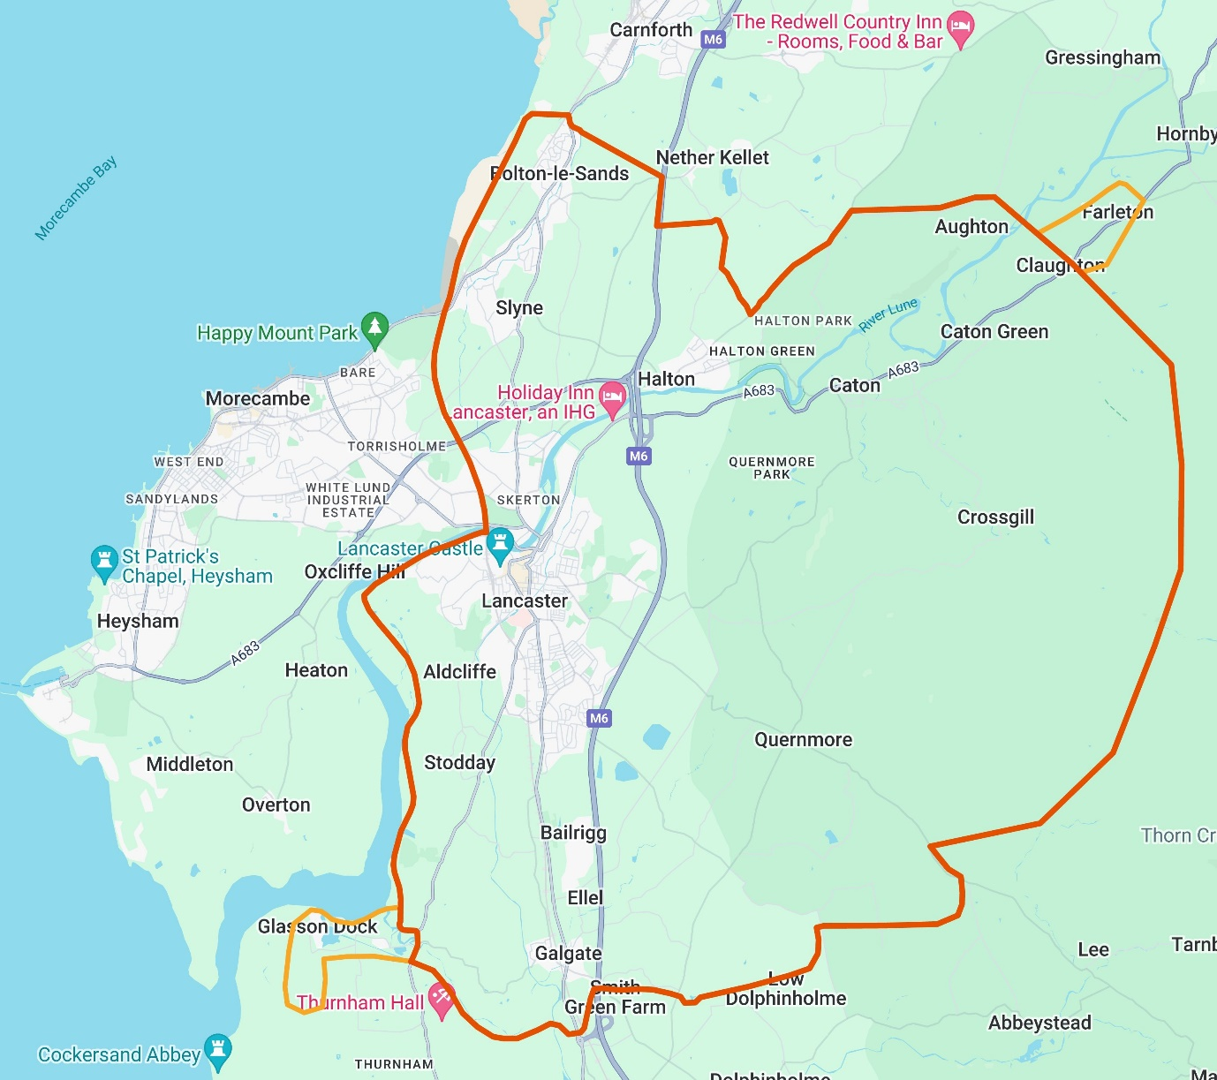
The practice does not cover:
Ryelands | Scale Hall | Westgate
Torrisholme | Bare | Morecambe
Heysham | Carnforth | The Kellets
Farleton | Hornby | Thurnham
Dolphinholme | Hampson Green

Registration
If you would like to register with the practice, please check with Reception at any site that your address is in the practice area. You can them complete a registration form, which can be done online, or if you cannot access this, you can collect a copy from Reception. If you take any regular medication, you will be required to speak with a member of our pharmacy team or a doctor before a prescription can be issued.

Change of Details
If you change your address, telephone number or mobile number please inform us as soon as possible.
If you are unsure whether your new address is within our practice area, please ask Reception.
It is important for us to keep your contact details up to date in case we need to contact you or a family member in an emergency.

Home Visits

We would like to remind patients that we can only do home visits for people who are medically housebound or terminally ill. We cannot visit under any other circumstances.

The doctor can see at least FOUR patients in surgery in the same time it takes to do ONE house-call. Please do not misuse this service.

If you feel a home visit is necessary, you must ring before 11:30am. Your request will be triaged by member of the clinical team and you may be rung back to find out more about your medical problem. If we feel there is a more appropriate way of helping you, we will offer this instead.

The Receptionist will ask you for some basic information to help the doctors and nurses assess and plan the visits.

Extended Hours
We have extended opening hours to accommodate those who find it difficult to get into surgery during normal surgery hours.

Appointments
If you require an urgent appointment, you will be given an appointment in the surgery that day to see a clinician where capacity allows. These appointments are shorter than routine and will only be able to address the single clinically urgent problem.
When we lack appointment capacity and our ability to continue to operate a safe service is compromised, you will be directed to an appropriate alternative service, such as 111.
If you require a non-urgent/routine appointment, our reception staff will add you to a waiting list until one becomes available. Wherever possible we will allocate you to your preferred GP, or to whichever GP/clinician may have already been dealing with the problem. There is good evidence to show that waiting slightly longer to see a clinician who knows your case will give better outcomes in the long term.
These appointments are in 15-minute slots and are where we can address longer term queries and concerns such as new non-urgent problems, chronic disease management, medication changes, follow ups etc. If you are aware that you have more than one problem which need to be discussed, please let the receptionist know so that we can allocate a double appointment.
When an appropriate routine appointment becomes available, we will send a booking link to your mobile device, this allows you to book an appointment for a time that suits you. If you are unable to use these booking links for any reason, please inform a member of the reception team and they will call you instead.
Once you have been allocated a routine appointment, we will not be able to bring this forward unless the problem becomes clinically urgent, in which case we would offer an urgent, on the day appointment.

Telephone Appointments
By default, all of our appointments are done face to face. If appropriate and necessary, some appointments can be carried out over the phone. Where possible we try to give you an approximate time at which the clinician will call you back. For this reason, it is important that your contact details are kept up to date.

Armed Forces Veteran Friendly Accredited GP Practice
Being accredited by the Royal College of General Practitioners means we can better identify veterans and help to improve future health provision. It also means that the NHS is better able to meet the health commitments of the Armed Forces Covenant, which says the Armed Forces community, including veterans, should face no disadvantage in accessing health services. Understanding the needs of our veterans will help us identify their healthcare needs better.
A veteran is someone who has served in the British Armed Forces (Regular or Reserve) for at least one day. Veterans also include any member of the Merchant Marine who has served in a war zone. This includes crew from convoys in World War 2 and more recently in the Falklands conflict and Gulf Wars.
Ask about our Armed Forces Veteran Questionnaire or find it on our website to let us know that you are a veteran, and make sure that you get the care you need.
For local support, please visit our care and support section, where you will find a list of support for veterans.

Carer Support
If you care for or look after a member of your family or neighbor because they are unable to perform daily tasks for themselves and if the caring role occupies many hours a week or makes a significant change to your lifestyle due to their disability or age, then you are a carer.
Ask about filling out our carer’s form or visit the page on our website to inform the practice that you are a paid or unpaid carer.

For local carers support, please visit our care and support section, where you will find a list of support for carers.

